Flipkart

Navigation bar (on top)

* Company name
* Avatar button (login/create account)
* Search bar
* Cart

Menu bar

* A horizontal division below navigation bar where different categories of items are available to see.

Advertisements and Offers and Banners Section

Filters

* Sort by price
* User rating
* Price ranges
* Popular brands
* discount

Item’s list

* Each item in separate division.
* Image of item and name
* Option to buy and add to cart
* Increase the quantity of item
* User rating
* Discount offers if available

Payment Page

* Address Section



* Payment Method (Credit/Debit Card, Net-Banking, UPI, Wallets, Paytm, Google Pay, PhonePe, EMI)

Format

Company Name  Search bar Account Cart

Advertisements, Offers and Banners Section



Categories

 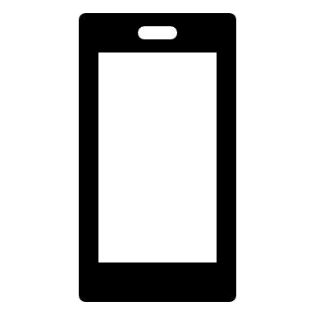 

Fashion Mobiles Electronics

Products

 